Q1.Write a script to open the Firefox browser and open https://www.google.com/
package selenium1;
import org.openqa.selenium.WebDriver;
import org.openqa.selenium.firefox.FirefoxDriver;

public class ques1 {

public static void main(String[] args) {
System.setProperty("webdriver.gecko.driver","/home/nisha/Desktop/seleniumFiles/geckodriver-v0.26.0-linux64/geckodriver");
WebDriver driver =new FirefoxDriver();
driver.get("http://google.com");
}

}

Output:
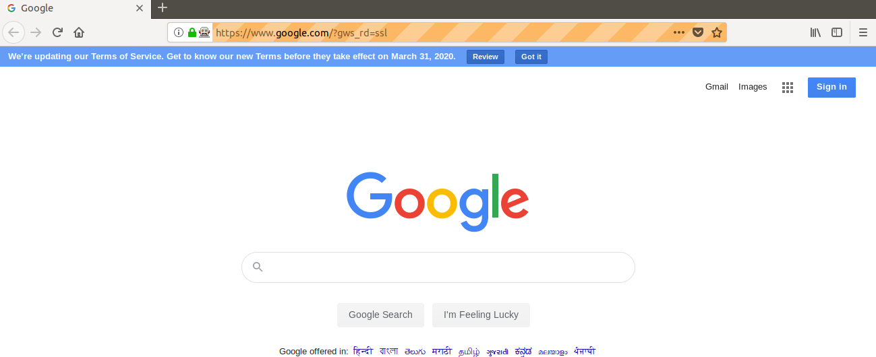

Q2.Write a script launch the Google Chrome browser and open https://www.google.com/
package selenium1;

import org.openqa.selenium.WebDriver;
import org.openqa.selenium.chrome.ChromeDriver;

public class ques2 {
public static void main(String[] args) {
System.setProperty("webdriver.chrome.driver", "/home/nisha/Desktop/seleniumFiles/chromedriver_linux64/chromedriver");
WebDriver driver = new ChromeDriver();

driver.get("http://google.com");

}

}

Output:
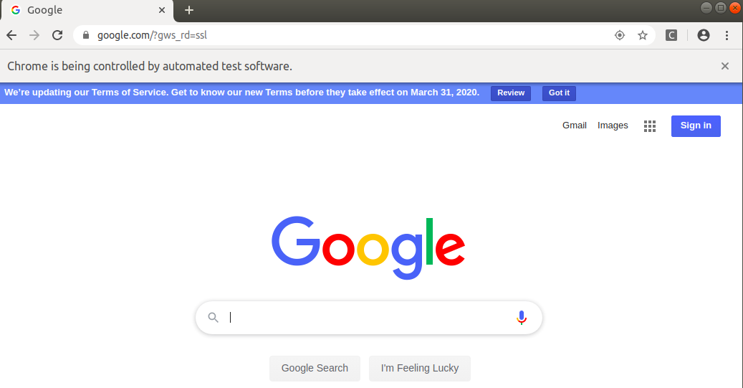

Q3.Write a script to search the “To The New” string in google.
package selenium1;

import org.openqa.selenium.By;
import org.openqa.selenium.WebDriver;
import org.openqa.selenium.WebElement;
import org.openqa.selenium.chrome.ChromeDriver;

public class ques3 {

public static void main(String[] args) {
System.setProperty("webdriver.chrome.driver", "/home/nisha/Desktop/seleniumFiles/chromedriver_linux64/chromedriver");
WebDriver driver = new ChromeDriver();

driver.get("http://google.com");
WebElement ele = driver.findElement(By.name("q"));
ele.sendKeys("to the new");
ele.submit();
}
}

Output:
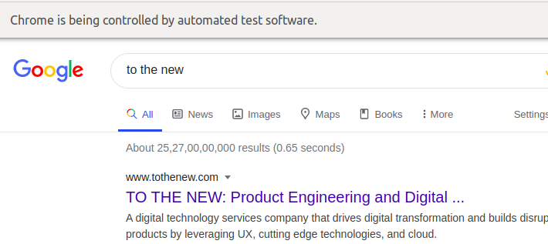

Q4.Write a script to open http://www.tothenew.com/ and then navigate to the contact us page using :
1) XPath
package selenium1;
import org.openqa.selenium.By;
import org.openqa.selenium.WebDriver;
import org.openqa.selenium.chrome.ChromeDriver;

public class ques4 {
public static void main(String[] args) {
System.setProperty("webdriver.chrome.driver", "/home/nisha/Desktop/seleniumFiles/chromedriver_linux64/chromedriver");
WebDriver driver = new ChromeDriver();

driver.navigate().to("http://www.tothenew.com/");
driver.findElement(By.xpath("/html/body/div[1]/div/header[2]/div/div/nav/div[2]/ul/li[8]/a")).click();
}
}
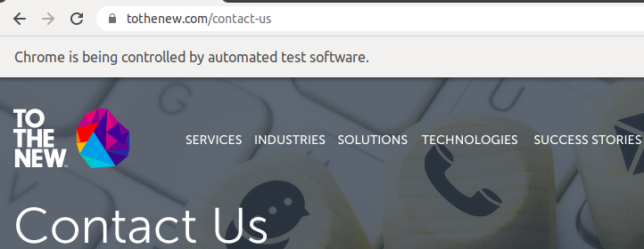

Q5.Write a script to get the title of the “Contact Us” page.

package selenium1;

import org.openqa.selenium.By;
import org.openqa.selenium.WebDriver;
import org.openqa.selenium.chrome.ChromeDriver;

public class ques5 {

public static void main(String[] args) {
System.setProperty("webdriver.chrome.driver", "/home/nisha/Desktop/seleniumFiles/chromedriver_linux64/chromedriver");
WebDriver driver = new ChromeDriver();

driver.navigate().to("http://www.tothenew.com/");
String title=driver.findElement(By.linkText("CONTACT US")).getText();
System.out.println(title);
}

}
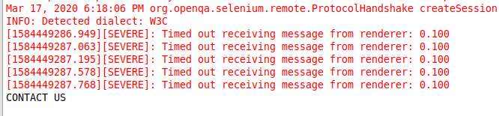

Q6.Write a script to get the url of the "Contact Us' page.
package selenium1;

import org.openqa.selenium.By;
import org.openqa.selenium.WebDriver;
import org.openqa.selenium.chrome.ChromeDriver;

public class ques6 {
public static void main(String[] args) {
System.setProperty("webdriver.chrome.driver", "/home/nisha/Desktop/seleniumFiles/chromedriver_linux64/chromedriver");
WebDriver driver = new ChromeDriver();

driver.navigate().to("http://www.tothenew.com/");
driver.findElement(By.linkText("CONTACT US")).click();
String title = driver.getCurrentUrl();
System.out.println(title);
}
}
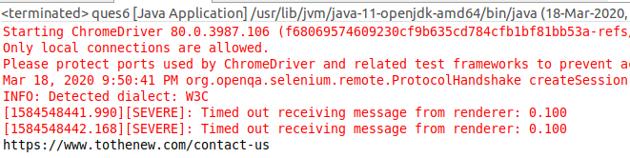

Q7.Write the disadvantages of selenium.
Ans.Disadvantages of selenium are:
1.Selenium only supports web based application and does not support windows based application.
2.It is difficult to test Image based application.
3.Difficult in coping with the page load and element load.
4.It can’t automate a captcha,otp and fingerprint.
5.Selenium does not support built in add-ins support.
6.It takes more time to create Test cases.
7.Selenium need outside support for report generation activity like dependence on TestNG or Jenkins.

Q8.Difference between get() & navigate() method
The get() is used to navigate to a page.The normal way to do this is by calling get.
Driver.get(“https://www.facebook.com/”) which loads a new web page in the current browser window. Webdriver will wait until the page has fully loaded before returning the control to test or script.

While driver.navigate.to() method navigates to an URL and it will not wait till the whole page gets loaded. It maintains the browser history and cookies, so we can use forward and backward button to navigate between the pages during the coding of Testcase.
driver.navigate().forward();
driver.navigate().back();

Q9.What is the difference between Selenium RC & Selenium WebDriver.
1.Remote Control which works by taking the remote of the browser and then injects the automation code to be tested by injecting the custom scripts written. Whereas the Web Driver works on the browser directly and uses browsers in-built features to trigger the automation test written by tester.
2.Selenium WebDriver performs faster than Selenium RC because it interacts directly with the browser without using any external proxy server. Selenium RC, on the other hand uses an intermediate RC Server to communicate with the browser.
3.Selenium RC API’s are less Object oriented whereas WebDriver API’s are entirely Object oriented.
4.Selenium WebDriver supports OS for mobile applications like ios, windows mobile and android. On the other hand, Selenium RC doesn't support testing of mobile applications.
5.Selenium WebDriver also supports headless HTMLUnit browser whereas Selenium RC doesn't support the headless HTMLUnit browser as it needs a real browser to work with.HTMLUnit is an invisible browser which facilitates faster execution of tests because it involves no time in waiting for page elements to load.

Q10.What are locators & types of locators in selenium
Locators are defined as an address that identifies a web element uniquely within the webpage.It is a command that tells Selenium IDE which GUI elements like – Text Box, Buttons, Check Boxes etc, it needs to operate on. Finding correct GUI elements is a prerequisite for creating an automation script.
Selenium provides a number of Locators to precisely locate a GUI element:
1.Id locator:
ID’s are unique for each element so it is common way to locate elements using ID Locator.
package intro;
import org.openqa.selenium.By;
import org.openqa.selenium.WebDriver;
import org.openqa.selenium.chrome.ChromeDriver;

public class FirstSelenium {

public static void main(String[] args) {
System.setProperty("webdriver.chrome.driver", "/home/nisha/Desktop/seleniumFiles/chromedriver_linux64/chromedriver");
WebDriver driver = new ChromeDriver();
driver.get("https://www.facebook.com/");
driver.findElement(By.id("email")).sendKeys("abc@gmail.com");
}
}
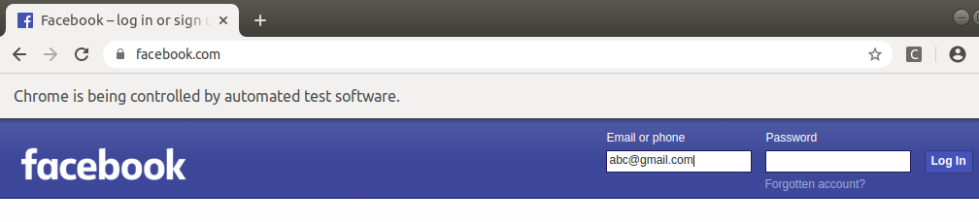

2.Name locator
Identify the elements on our webpage. Locating elements using Name is same as locating elements using ID locator.
These are not unique on a page. If there are multiple elements with the same Name locator then the first element on the page is selected. Test may fail, if another element with the same Name locator is present on the web page or added by the developers in the later stages.

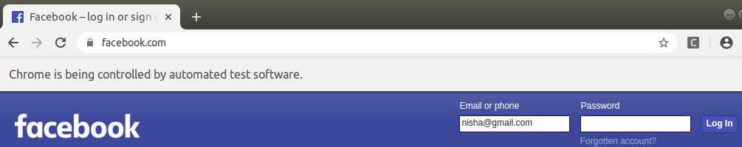
3.linkText
package intro;
import org.openqa.selenium.By;
import org.openqa.selenium.WebDriver;
import org.openqa.selenium.chrome.ChromeDriver;

public class FirstSelenium {
public static void main(String[] args) {
System.setProperty("webdriver.chrome.driver", "/home/nisha/Desktop/seleniumFiles/chromedriver_linux64/chromedriver");
WebDriver driver = new ChromeDriver();
driver.get("https://www.tothenew.com/");
driver.findElement(By.linkText("CONTACT US")).click();
}
}

Partial linkText
package intro;

import org.openqa.selenium.By;
import org.openqa.selenium.WebDriver;
import org.openqa.selenium.chrome.ChromeDriver;

public class FirstSelenium {
public static void main(String[] args) {
System.setProperty("webdriver.chrome.driver", "/home/nisha/Desktop/seleniumFiles/chromedriver_linux64/chromedriver");
WebDriver driver = new ChromeDriver();
driver.get("https://www.tothenew.com/");
driver.findElement(By.partialLinkText("CONTACT")).click();
}
}

4.CSS Selector
package intro;
import org.openqa.selenium.By;
import org.openqa.selenium.WebDriver;
import org.openqa.selenium.chrome.ChromeDriver;

public class FirstSelenium {
public static void main(String[] args) {
System.setProperty("webdriver.chrome.driver", "/home/nisha/Desktop/seleniumFiles/chromedriver_linux64/chromedriver");
WebDriver driver = new ChromeDriver();
driver.get("https://www.facebook.com/");
driver.findElement(By.cssSelector("input#email")).sendKeys("nisha@gmail.com");
}
}

5.Xpath
package intro;
import org.openqa.selenium.By;
import org.openqa.selenium.WebDriver;
import org.openqa.selenium.chrome.ChromeDriver;

public class FirstSelenium {
public static void main(String[] args) {
System.setProperty("webdriver.chrome.driver", "/home/nisha/Desktop/seleniumFiles/chromedriver_linux64/chromedriver");
WebDriver driver = new ChromeDriver();
driver.get("https://www.facebook.com/");
driver.findElement(By.xpath("//*[@id='email']")).sendKeys("abc");
}
}

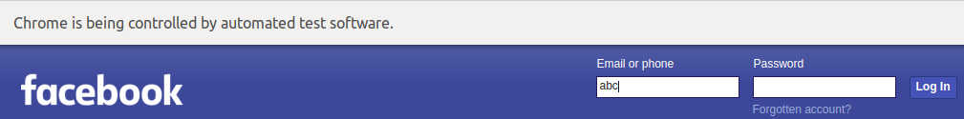

Q11.Write an automation script for filling all fields of the registration page. (Registration.html)
Script For filling all fields:
package selenium1;
import org.openqa.selenium.By;
import org.openqa.selenium.Keys;
import org.openqa.selenium.WebDriver;
import org.openqa.selenium.WebElement;
import org.openqa.selenium.chrome.ChromeDriver;
import org.openqa.selenium.support.ui.Select;

public class ques11 {
public static void main(String[] args) {
System.setProperty("webdriver.chrome.driver", "/home/nisha/Desktop/seleniumFiles/chromedriver_linux64/chromedriver");
WebDriver driver = new ChromeDriver();
driver.navigate().to("http://demo.automationtesting.in/Register.html");

driver.findElement(By.xpath ("//*[@id=\"basicBootstrapForm\"]/div[1]/div[1]/input")).sendKeys("nisha");
driver.findElement(By.xpath("/html/body/section/div/div/div[2]/form/div[1]/div[2]/input")).sendKeys("N");
driver.findElement(By.xpath("/html/body/section/div/div/div[2]/form/div[2]/div/textarea")).sendKeys("B-130,Dwarka,New Delhi");
driver.findElement(By.xpath("/html/body/section/div/div/div[2]/form/div[3]/div[1]/input")).sendKeys("nisha@gmail.com");
driver.findElement(By.xpath("/html/body/section/div/div/div[2]/form/div[4]/div/input")).sendKeys("123456");
driver.findElement(By.xpath("/html/body/section/div/div/div[2]/form/div[5]/div/label[2]/input")).click();
driver.findElement(By.xpath("//*[@id=\"checkbox3\"]")).click();

try {
driver.findElement(By.id("msdd")).click();
driver.findElement(By.xpath("//*[@id=\"basicBootstrapForm\"]/div[7]/div/multi-select/div[2]/ul/li[8]/a")).click();
Thread.sleep(500);
}catch(Exception e){
System.out.println(e);
}
try {
Thread.sleep(2500);
Select skill = new Select(driver.findElement(By.id("Skills")));
skill.selectByIndex(2);
Select country1 = new Select(driver.findElement(By.id("countries")));
country1.selectByIndex(4);
WebElement countryOptionClick= driver.findElement(By.xpath("/html/body/section/div/div/div[2]/form/div[10]/div/span/span[1]/span"));
countryOptionClick.click(); driver.findElement(By.xpath("/html/body/span/span/span[1]/input")).sendKeys("Japan"); driver.findElement(By.xpath("/html/body/span/span/span[1]/input")).sendKeys(Keys.ENTER);
}catch(Exception e){
System.out.println(e);
}
try {
Thread.sleep(2500);
Select country2 = new Select(driver.findElement(By.className("select2-selection select2-selection--single")));
country2.selectByVisibleText("India");
}catch(Exception e){
System.out.println(e);
}
try {
Select year = new Select(driver.findElement(By.id("yearbox")));
year.selectByValue("1997");
Thread.sleep(2000);
Select month = new Select(driver.findElement(By.xpath("/html/body/section/div/div/div[2]/form/div[11]/div[2]/select")));
month.selectByValue("May");
}catch(Exception e) {
System.out.print(e);
}
try {
Thread.sleep(2000);
Select day = new Select(driver.findElement(By.id("daybox")));
day.selectByValue("7");
}catch(Exception e) {
System.out.print(e);
}
driver.findElement(By.id("firstpassword")).sendKeys("pass123");
driver.findElement(By.id("secondpassword")).sendKeys("pass123");
}
}
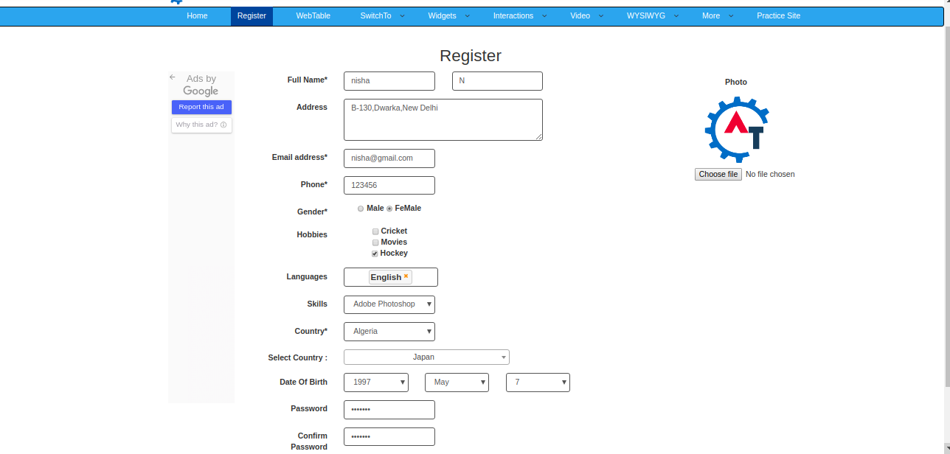
a- Validate that Refresh button is disabled.
package selenium1;
import org.openqa.selenium.By;
import org.openqa.selenium.WebDriver;
import org.openqa.selenium.WebElement;
import org.openqa.selenium.chrome.ChromeDriver;

public class Ques11a {
public static void main(String[] args) {
System.setProperty("webdriver.chrome.driver", "/home/nisha/Desktop/seleniumFiles/chromedriver_linux64/chromedriver");
WebDriver driver = new ChromeDriver();
driver.navigate().to("http://demo.automationtesting.in/Register.html");
driver.findElement(By.xpath("//*[@id=\"basicBootstrapForm\"]/div[1]/div[1]/input")).sendKeys("nisha");
driver.findElement(By.xpath("//*[@id=\"basicBootstrapForm\"]/div[1]/div[2]/input")).sendKeys("N");
try {
Thread.sleep(3000);
}catch(Exception e) {
System.out.println(e);
}
WebElement refreshButton = driver.findElement(By.id("Button1"));
if(refreshButton.isEnabled()) {
driver.findElement(By.id("Button1")).click();
System.out.println("Refresh button is enabled");
}else
{
System.out.println("Refresh button is disabled");
}
}
}

b- Validate that your respective gender is selected or not.
package selenium1;
import org.openqa.selenium.By;
import org.openqa.selenium.WebDriver;
import org.openqa.selenium.chrome.ChromeDriver;

public class Ques11b {
public static void main(String[] args) {
System.setProperty("webdriver.chrome.driver", "/home/nisha/Desktop/seleniumFiles/chromedriver_linux64/chromedriver");
WebDriver driver = new ChromeDriver();
driver.navigate().to("http://demo.automationtesting.in/Register.html");
try {
driver.findElement(By.xpath("/html/body/section/div/div/div[2]/form/div[5]/div/label[2]/input")).click();
Thread.sleep(3000);
}catch(Exception e) {
System.out.println(e);
}
driver.findElement(By.xpath("/html/body/section/div/div/div[2]/form/div[5]/div/label[1]/input")).click();
}
}

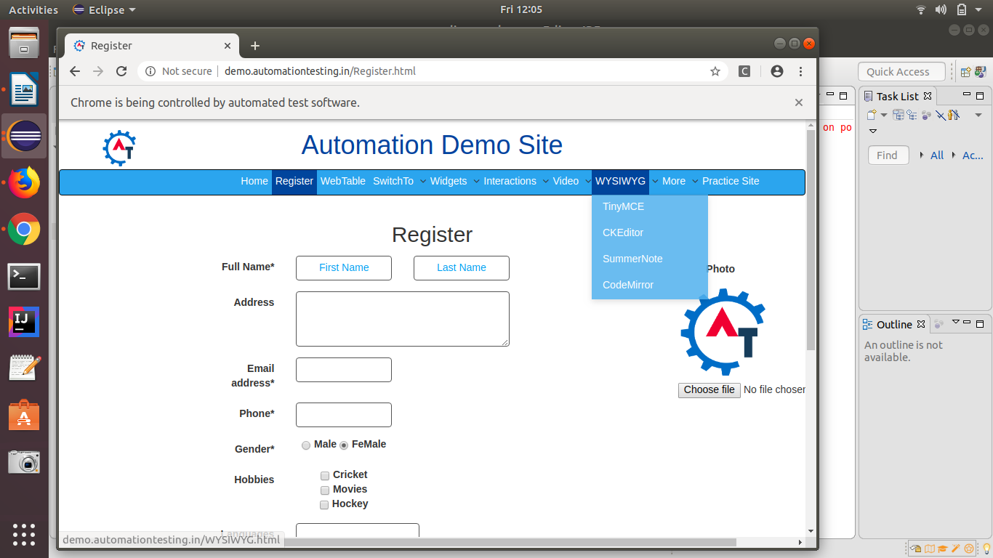
Initially the gender selected is female, then Thread.sleep(3000) is executed.

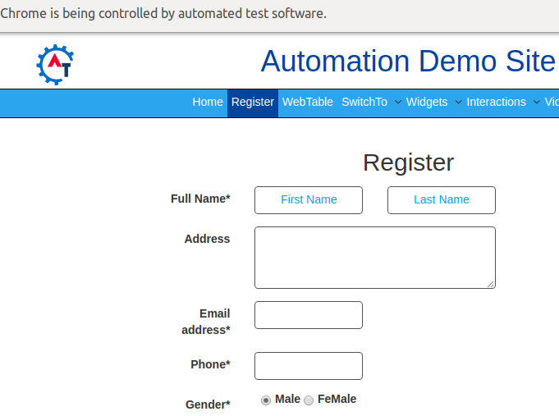
After Thread.sleep(3000) is executed,the gender selected is male.
c- Validate that header of the registration page is Automation Demo Site.
package selenium1;

import org.openqa.selenium.By;
import org.openqa.selenium.WebDriver;
import org.openqa.selenium.chrome.ChromeDriver;

public class Ques11c {
public static void main(String[] args) {
System.setProperty("webdriver.chrome.driver", "/home/nisha/Desktop/seleniumFiles/chromedriver_linux64/chromedriver");
WebDriver driver = new ChromeDriver();

driver.navigate().to("http://demo.automationtesting.in/Register.html");
String title = driver.findElement(By.xpath("//*[@id=\"header\"]/div/div/div/div[2]/h1")).getText();
System.out.println("Heading of page is: " +title);
}
}

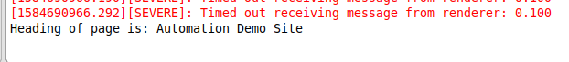

d- Validate that title of the page is Register.
package selenium1;

import org.openqa.selenium.WebDriver;
import org.openqa.selenium.chrome.ChromeDriver;

public class Ques11d {

public static void main(String[] args) {
System.setProperty("webdriver.chrome.driver", "/home/nisha/Desktop/seleniumFiles/chromedriver_linux64/chromedriver");
WebDriver driver = new ChromeDriver();

driver.navigate().to("http://demo.automationtesting.in/Register.html");
String pageTitle = driver.getTitle();
System.out.println("Title of page is: "+pageTitle);
}

}
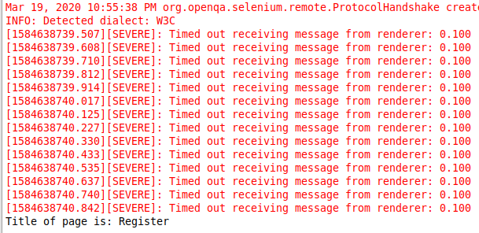

Q12 Write an automation script for filling FirstName, LastName & Email address field with the help of name locator. (Registration.html)
package selenium1;

import org.openqa.selenium.By;
import org.openqa.selenium.WebDriver;
import org.openqa.selenium.chrome.ChromeDriver;

public class ques12 {
public static void main(String[] args) {
System.setProperty("webdriver.chrome.driver", "/home/nisha/Desktop/seleniumFiles/chromedriver_linux64/chromedriver");
WebDriver driver = new ChromeDriver();

driver.navigate().to("http://demo.automationtesting.in/Register.html");
driver.findElement(By.xpath("//*[@id=\"basicBootstrapForm\"]/div[1]/div[1]/input")).sendKeys("nisha");
driver.findElement(By.xpath("//*[@id=\"basicBootstrapForm\"]/div[1]/div[2]/input")).sendKeys("N");
driver.findElement(By.xpath("//*[@id=\"eid\"]/input")).sendKeys("nisha@gmail.com");

}
}

